1. **Detail Planning**
2. **Data Flow Diagram**

* **Context Level**

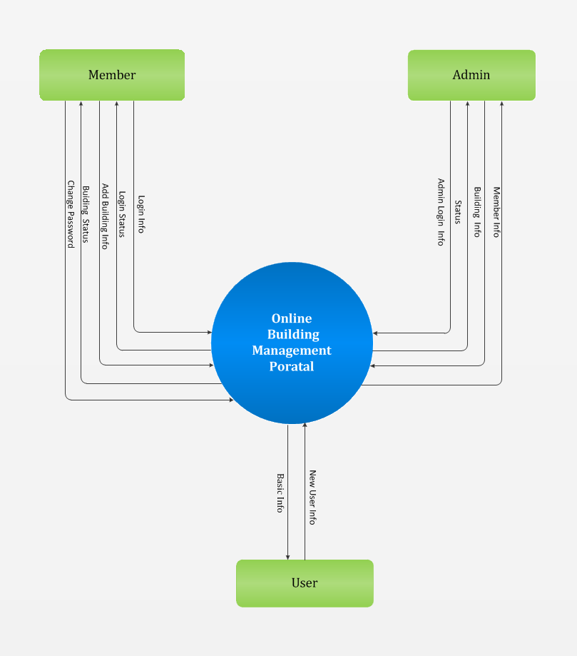

* **1st Level DFD**

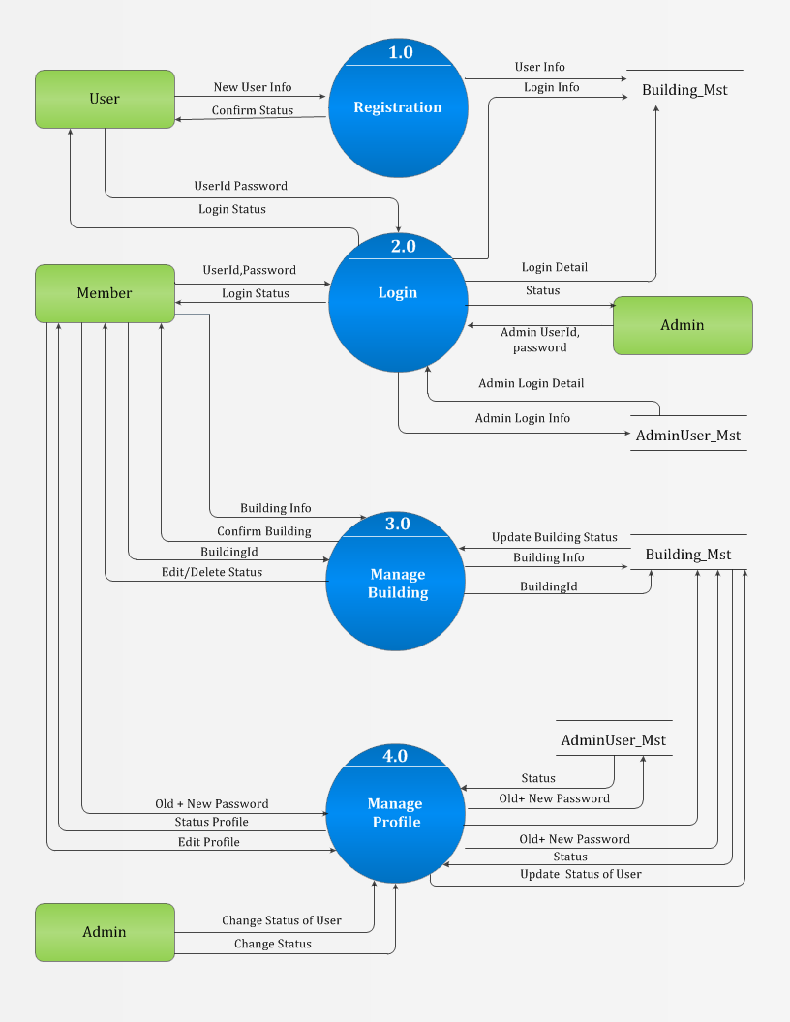

* **2nd Level DFD For Registration process 1.0**

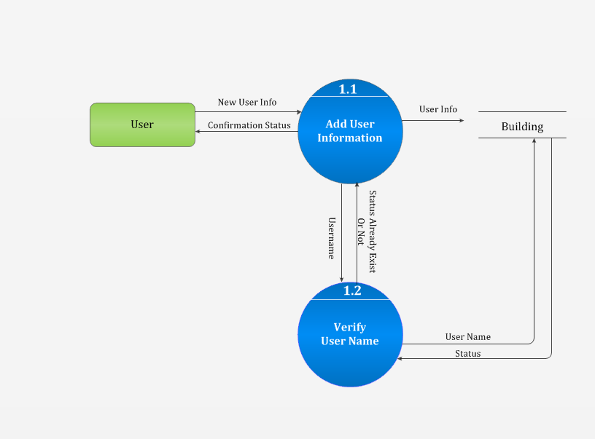

* **2nd Level DFD For Login process 2.0**

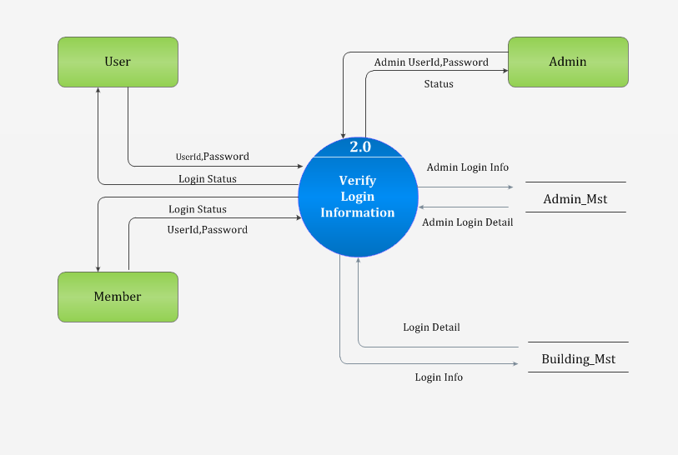

* **2nd Level DFD For Manage Building process 3.0**

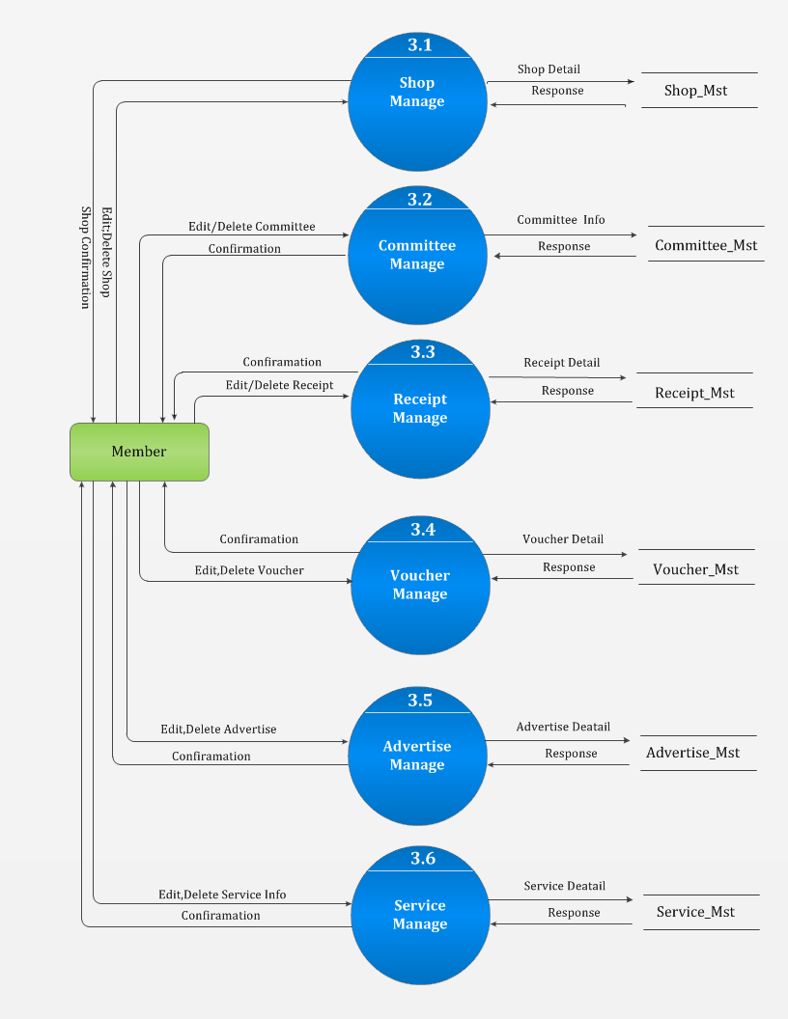

* **2nd Level DFD For Manage profile 4.0**

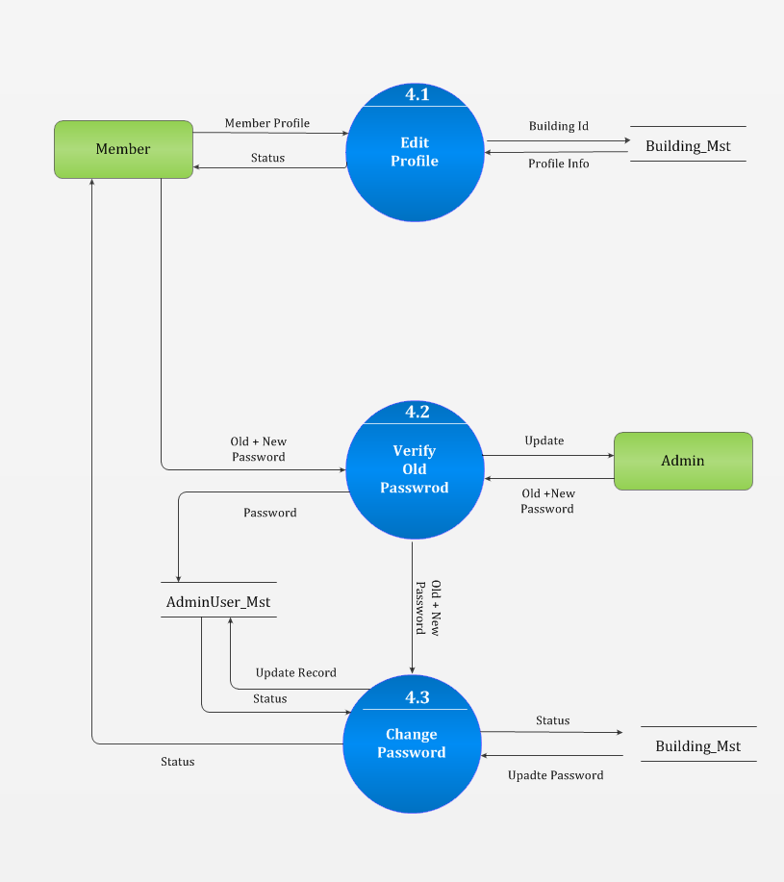

**6.2 Process Specification**

* **User Registration Process**

User

info

User

Registration

This process checks the information of and checks whether he/she is already registered or not. If already registered then give error message.

* **Admin/Member Login process**

Admin/Member Info

Information Of

Admin/Member login

This process checks the information of admin/member and check whether he/she is registered or not and display the admin page or home page else give error message and redirect to login page again.

* **Change password process**

old & new

Password info

This process check old password of current member and if it matched than replace with new password provided by member else give error message

New password info

* Create user process
* **Building process**

Building Info

New Building info

This process add a new Building which is provided by member before add a Building check the Building already added or not and appropriate message display.

* **Manage profile**

Edit profile info

Status

This process edit the profile information concerned along with the change password process and return the status of success.

* **Manage Shop Process**

Shop Info

Status

This process check the new arrival Shop is already exists in database or not if it is present already then it give error otherwise add the Shop information.

* **Manage Committee Process**

Committee info

Committee info

This process check the new arrival Committee is already exists in database or not if it is present already then it give error otherwise add the Committee information.

.

* **Manage Advertise process**

Advertise Information

Advertise details

This process check the new arrival Advertise is already exists in database or not if it is present already then it give error otherwise add the Advertise information.

* **Manage Voucher Process**

Voucher info

Voucher Detail

This process check the new arrival Voucher is already exists in database or not if it is present already then it give error otherwise add the Voucher information.

.

* **Manage Service process**

Service

Information

service details

This process check the new arrival Service is already exists in database or not if it is present already then it give error otherwise add the Service information.

**6.3 Data Dictionary**

* **Name : add user information**

**Source** : user entity

**Destination** : 1.0 user registration process

**Where/how used** : whenever new user want to a member to system

**Content description** : username + password + other information

* **Name : admin Login info**

**Source** : admin entity

**Destination** : 2.0 user login process

**Where/how used** : whenever the admin want to login into the system

**Content description** : username + password

* **Name : Manage Building**

**Source**  : user entity

**Destination** : 3.0 Building process

**Where/how used** : whenever the new user want edit/delete Building

Info

**Content description** : Building Id

* Name : Manage Profile

**Source** : user entity

**Destination** : 4.0 profile process

**Where/how used** : whenever the Member change the information into the system

**Content description** : Building Id

* **Name Manage shop**

**Source** : client entity

**Destination** : 3.1 Manage shop process

**Where/how used** : whenever the new client want edit/delete shop info

**Content description** : building id

* **Name committee Info**

**Source** : client entity

**Destination** : 3.2 manage committee info

**Where/how used** : whenever the new client want edit/delete

Committee **Information**

**Content description** : committee id

* **Name Manage Receipt**

**Source** : client entity

**Destination** : 3.3 manage & generate receipt info

**Where/how used** : whenever the new client want edit/delete Receipt

Information

**Content description** : receipt id

* **Name Manage Voucher**

**Source**  : client entity

**Destination** : 3.4 manage Voucher information

**Where/how used** : whenever the new client want edit/delete Voucher

**Information**

**Content description** : Voucher id

* **Name Manage Advertise**

**Source**  : client entity

**Destination** : 3.5 manage advertise information

**Where/how used** : whenever the new client want edit/delete Advertise

**Information**

**Content description** : advertise id

* **Name Manage Service**

**Source**  : client entity

**Destination** : 3.6 manage Service information

**Where/how used** : whenever the new client want edit/delete Service

**Information**

**Content description** : Service id

* **Name : Edit Profile**

**Source** : client entity

**Destination** : 4.1 change status of user profile

**Where/how used** : whenever the admin want to change status of

Profile Content

**Description** : building id

**6.4 Entity-Relationship Diagram**

